Homework 4

name: Zichen Pan UNI: zp2197

Problem 1

(a)

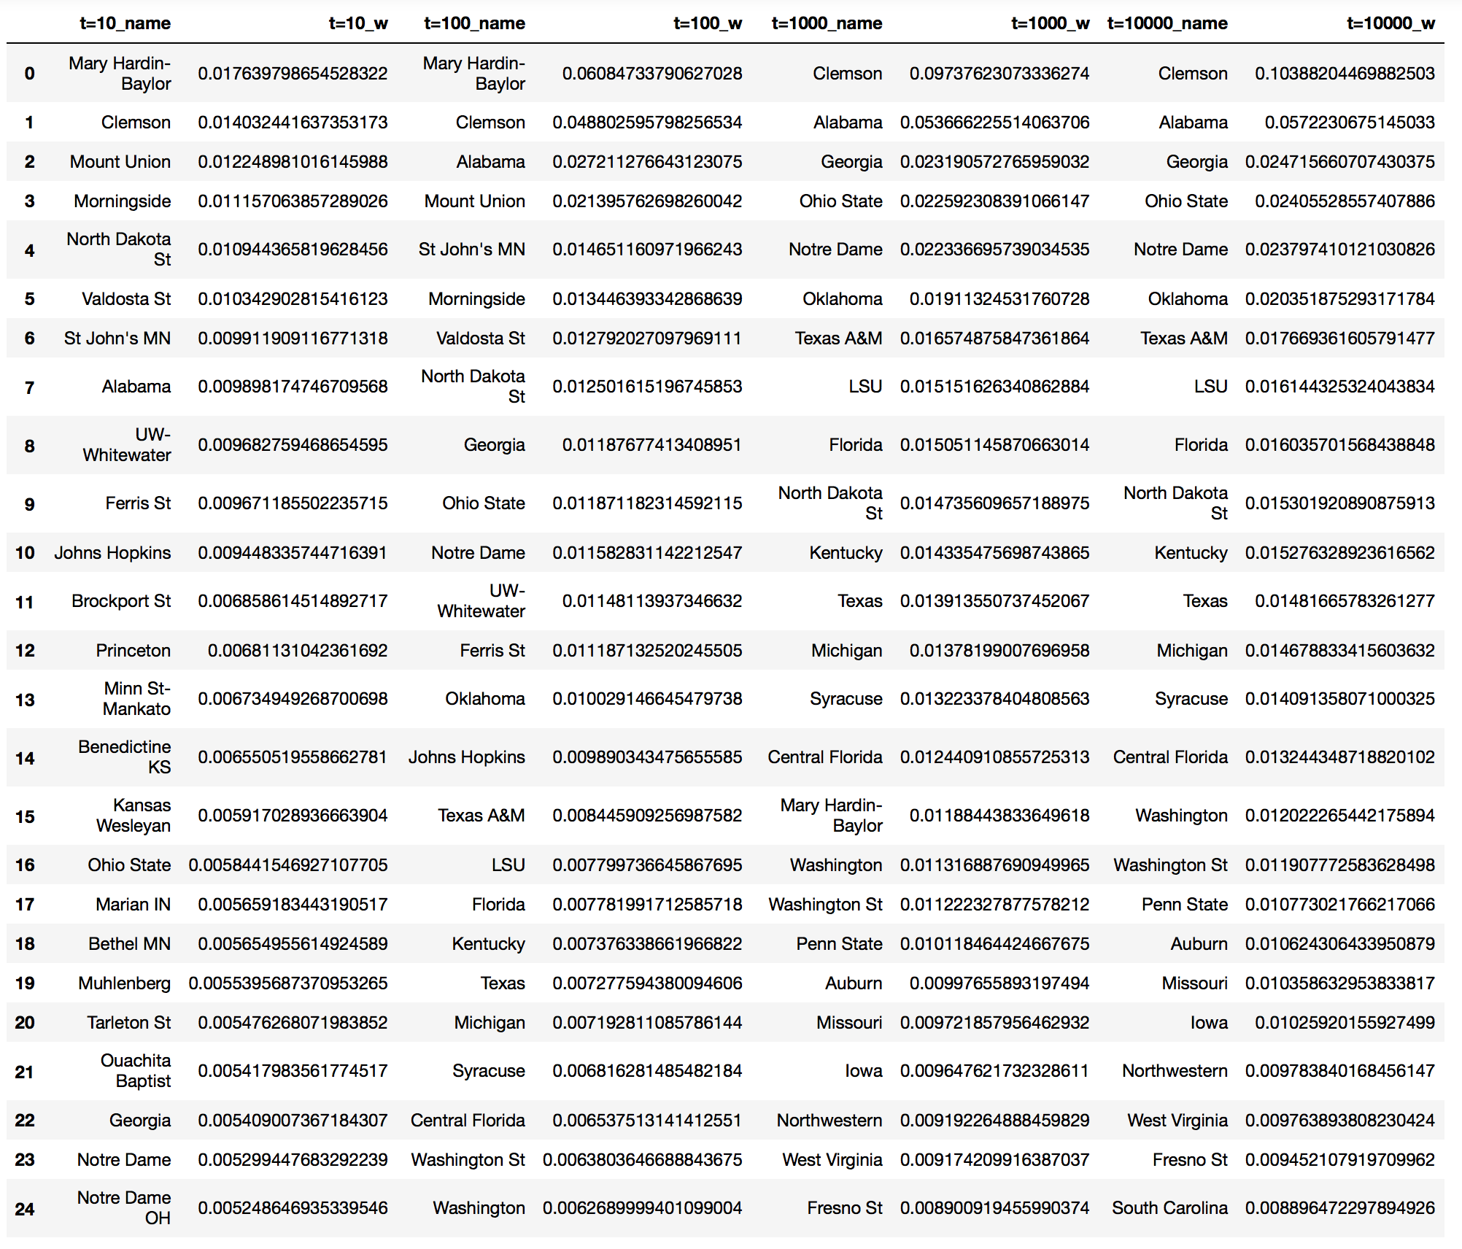

(b)

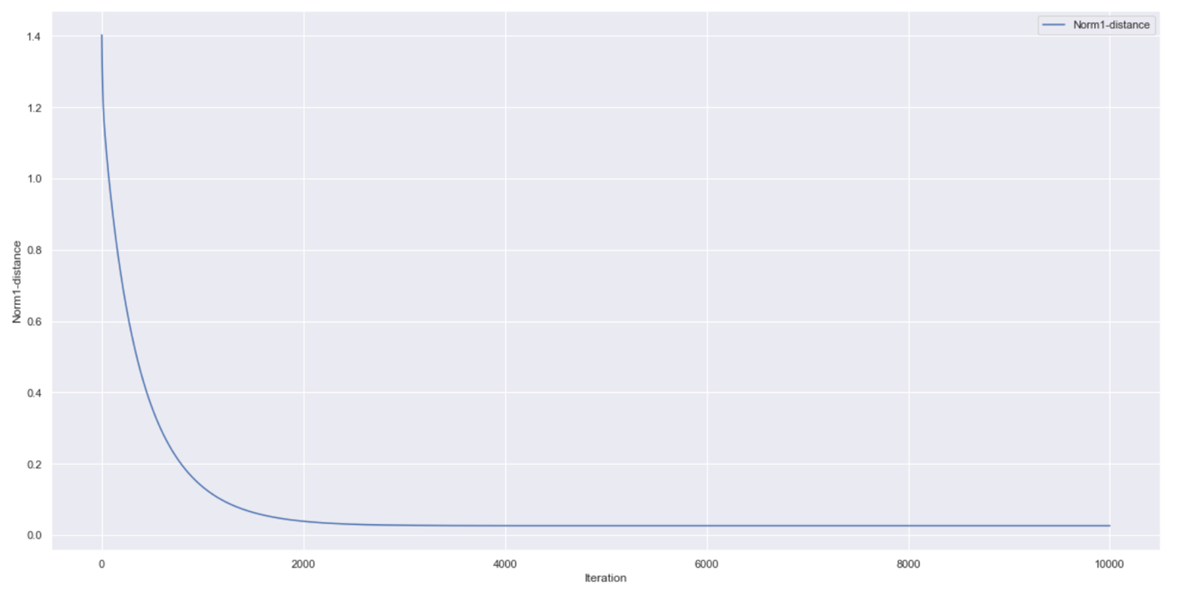

Problem 2

(a)

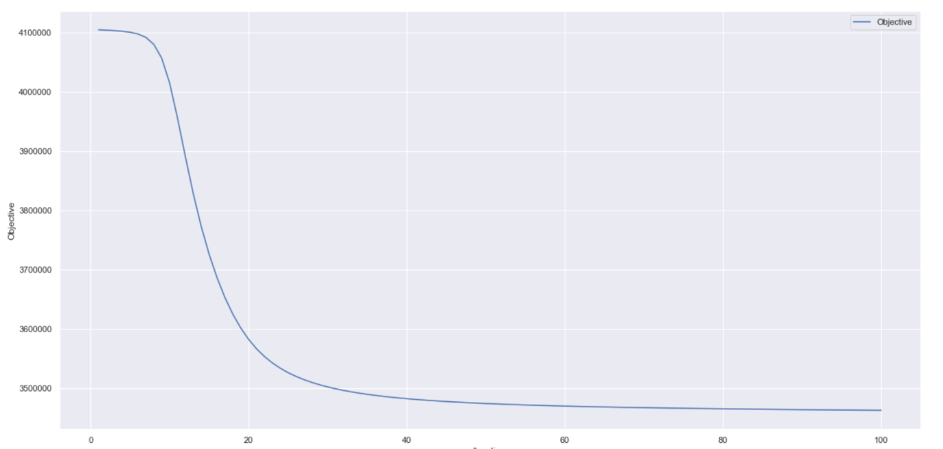

(b)

|  |  |  |  |  |
| --- | --- | --- | --- | --- |
|  |  |  |  |  |
|  |  |  |  |  |
|  |  |  |  |  |
|  |  |  |  |  |
|  |  |  |  |  |